**Assignment 2 Template**

**LAST NAME: Yuan**

**FIRST NAME: Feng**

**USERID: y87feng**

**UWaterloo ID: 20600787**

**Problem 1: Fill in the information below based on your Binomial observation which was generated using your ID number as the random seed.**

**theta = 0.3430096 y =11**

**The maximum likelihood of theta is thetahat = 0.275**

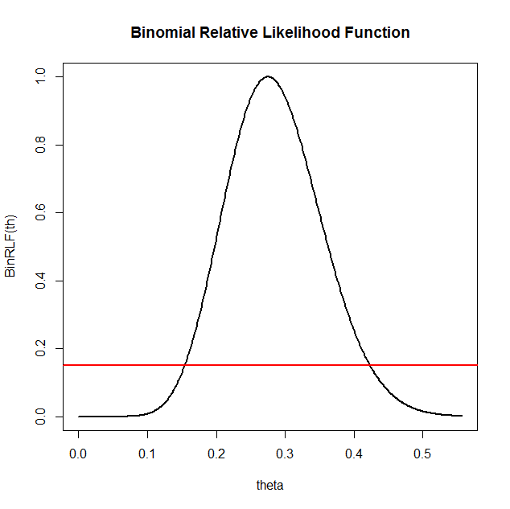

**Based on the graph of the relative likelihood function and the line y = 0.15 the 15% likelihood interval for theta is: [0.17,0.42]**

**Using the R function uniroot the 15% likelihood interval is:**

**[0.1541311,0.4235292]**

**(NOTE: To find the endpoints of the likelihood interval using**

uniroot(function(x) BinRLF(x)-0.15,lower=0.1,upper=0.15)

**you will need to change** “lower=0.1,upper=0.15” **to values that work for your data.)**

**Is theta = 0.2 a plausible value of theta for your data set? Why?**

**Theta = 0.2 is an plausible value of theta since the corresponding value is greater than 0.1 and less than 0.5 in the graph**

**Is theta = 0.8 a plausible value of theta for your data set? Why?**

**Theta = 0.8 is a very implausible value of theta since it is greater than 0.5, the corresponding value is less than 0.01**

**Problem 2: The first three numbers in your Exponential data set are:**

|  |  |  |
| --- | --- | --- |
| **0.1487426** | **0.2557913** | **0.3369800** |

**theta = 13.68846**

**The maximum likelihood of theta is thetahat = 12.19222**

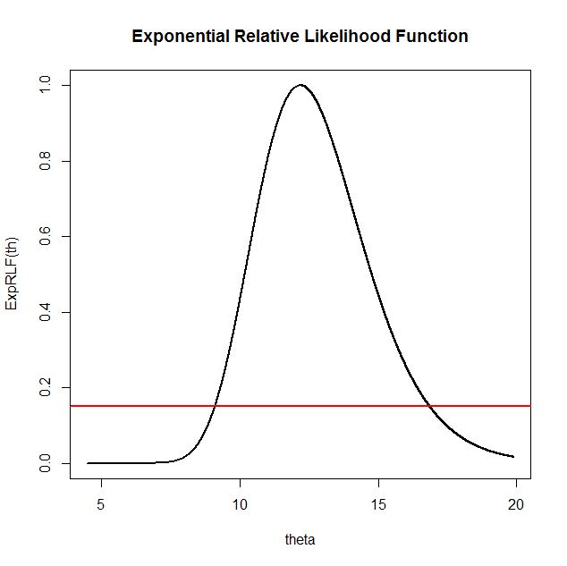

**Based on the graph of the relative likelihood function and the line y = 0.15 the 15% likelihood interval for theta is: [9,17]**

**Using the R function uniroot the 15% likelihood interval is:**

**(NOTE: To find the endpoints of the likelihood interval using**

uniroot(function(x) ExpRLF(x)-0.15,lower=2.8,upper=3)

**you will need to change** “lower=2.8,upper=3” **to values that work for your data.)**

**[9.096035,16.86836]**

**Is theta = 2 a plausible value of theta for your data set? Why?**

**Theta = 2 is a very implausible value of theta since it is less than 5, the corresponding value is less than 0.01**

**Is theta = 8 a plausible value of theta for your data set? Why?**

**Theta = 8 is an implausible value of theta since the 10% likelihood interval is approximately [8.8,17.5] by using R code, 8 < 8.8, thus it is implausible.**

**If Y is a new observation from this Exponential distribution then the maximum likelihood estimate of P(Y > 1) is: e^(-12.19222)**

**Problem 3:**

**population mean =7.106**

**population standard deviation = 2.712704**

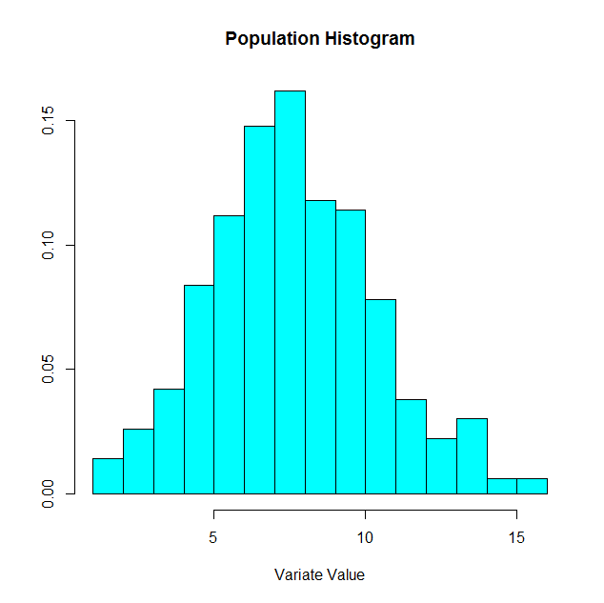

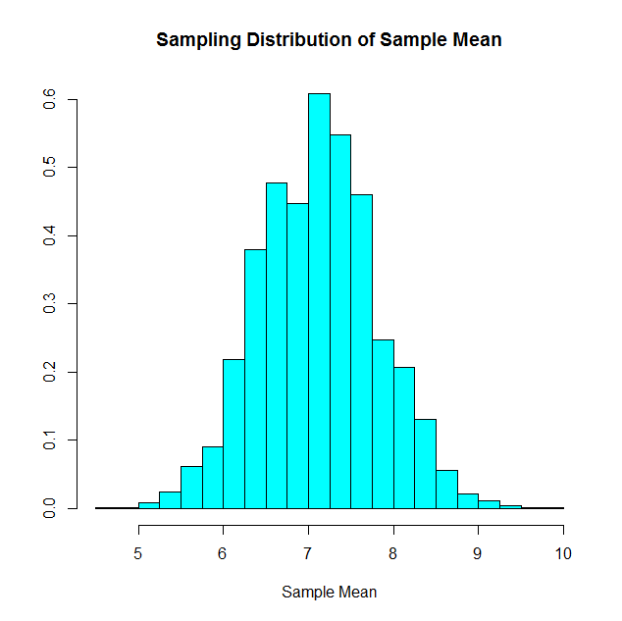

**What factor(s) affect the location of the sampling distribution of the sample mean?**

The way that the sample is chosen.

**What factor(s) affect the spread of the sampling distribution of the sample mean?**

The [spread](http://davidmlane.com/hyperstat/A84400.html) of the sampling distribution of the mean decreases as the sample size increases.

**What factor(s) affect the shape of the sampling distribution of the sample mean?**

The sampling distribution of the mean approaches a normal distribution as sample size increases